Veg h 🡪 Soil T

Global model

lm(formula = meanT ~ veg_h_mean * pop, data = data6)

Estimate Std. Error t value Pr(>|t|)

(Intercept) 18.378708 0.310201 59.248 < 2e-16 ***

veg_h_mean -0.049860 0.008536 -5.841 1.40e-08 ***

popR -1.760718 0.421004 -4.182 3.83e-05 ***

popT -0.125164 0.383500 -0.326 0.7444

veg_h_mean:popR 0.026743 0.012461 2.146 0.0327 *

veg_h_mean:popT 0.025606 0.013077 1.958 0.0512 .



Models for each population

> summary(lm(meanT~veg_h_mean,data=subset(data6,pop=="H")))

Estimate Std. Error t value Pr(>|t|)

(Intercept) 18.37871 0.39437 46.602 < 2e-16 ***

veg_h_mean -0.04986 0.01085 -4.594 1.31e-05 ***

Multiple R-squared: 0.1787, Adjusted R-squared: 0.1702

> summary(lm(meanT~veg_h_mean,data=subset(data6,pop=="R")))

Estimate Std. Error t value Pr(>|t|)

(Intercept) 16.617989 0.262506 63.305 < 2e-16 ***

veg_h_mean -0.023117 0.008372 -2.761 0.00696 **

Multiple R-squared: 0.07731, Adjusted R-squared: 0.06717

> summary(lm(meanT~veg_h_mean,data=subset(data6,pop=="T")))

Estimate Std. Error t value Pr(>|t|)

(Intercept) 18.253543 0.166126 109.878 < 2e-16 ***

veg_h_mean -0.024254 0.007298 -3.323 0.00124 **

Multiple R-squared: 0.09857, Adjusted R-squared: 0.08965

Significant negative effect on each of the 3 populations: temperature decreases with vegetation height in all 3 populations and the decrease is stronger in population H

Soil T 🡪 Phen

Using average phen_index (higher values = earlier flowering)

Global model

Result from model selection from global model including temperature, vegetation height, population + interactions

Estimate Std. Error t value Pr(>|t|)

(Intercept) -1.639798 0.985962 -1.663 0.097371 .

meanT 0.228518 0.056108 4.073 6.01e-05 ***

popR 4.300850 1.585035 2.713 0.007061 **

popT 0.178447 1.926274 0.093 0.926255

veg_h_mean 0.015508 0.004198 3.695 0.000264 ***

meanT:popR -0.254606 0.097836 -2.602 0.009737 **

meanT:popT 0.057553 0.109988 0.523 0.601187

Multiple R-squared: 0.4475, Adjusted R-squared: 0.4359

The effect of temperature differs among populations. The effect of vegetation height does not differ among populations and plants flower earlier where the vegetation is higher.

Models for each population

H

Estimate Std. Error t value Pr(>|t|)

(Intercept) -1.000826 1.153703 -0.867 0.38784

meanT 0.204223 0.061417 3.325 0.00125 **

veg_h_mean 0.008730 0.007244 1.205 0.23109

Multiple R-squared: 0.1037, Adjusted R-squared: 0.08502

R

Estimate Std. Error t value Pr(>|t|)

(Intercept) 2.097259 1.624291 1.291 0.19995

meanT -0.003293 0.096652 -0.034 0.97290

veg_h_mean 0.022324 0.008036 2.778 0.00665 **

Multiple R-squared: 0.08558, Adjusted R-squared: 0.06526

T

Estimate Std. Error t value Pr(>|t|)

(Intercept) -1.462125 1.521039 -0.961 0.338737

meanT 0.286105 0.082982 3.448 0.000828 ***

veg_h_mean 0.015517 0.006411 2.421 0.017303 *

Multiple R-squared: 0.1218, Adjusted R-squared: 0.1043

Adding number of flowers as a covariate

H

Estimate Std. Error t value Pr(>|t|)

(Intercept) -0.258208 1.207435 -0.214 0.83112

n_fl -0.100983 0.054386 -1.857 0.06644 .

meanT 0.175762 0.062556 2.810 0.00602 **

veg_h_mean 0.008071 0.007162 1.127 0.26259

Multiple R-squared: 0.1351, Adjusted R-squared: 0.1078

R

Estimate Std. Error t value Pr(>|t|)

(Intercept) 2.005981 1.596046 1.257 0.2121

n_fl 0.090110 0.043532 2.070 0.0414 *

meanT -0.002301 0.094936 -0.024 0.9807

veg_h_mean 0.016029 0.008458 1.895 0.0613 .

Multiple R-squared: 0.1276, Adjusted R-squared: 0.09818

T

Estimate Std. Error t value Pr(>|t|)

(Intercept) -2.068691 1.473748 -1.404 0.163539

n_fl 0.051885 0.016867 3.076 0.002712 **

meanT 0.306573 0.079956 3.834 0.000222 ***

veg_h_mean 0.010623 0.006358 1.671 0.097897 .

Multiple R-squared: 0.1984, Adjusted R-squared: 0.1742

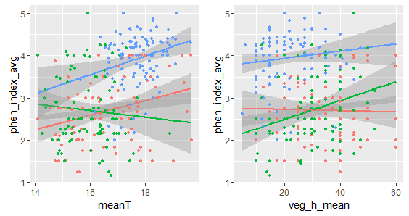

Using day when phen_index=3 (higher values = later flowering)

Global model

Result from model selection from a global model including temperature, vegetation height, population, and their two-way interactions

Estimate Std. Error Adjusted SE z value Pr(>|z|)

(Intercept) 283.28978 15.53357 15.58997 18.171 < 2e-16 ***

meanT -2.49664 0.88346 0.88662 2.816 0.004864 **

popR -37.65486 31.91823 31.97097 1.178 0.238883

popT -12.61778 24.75602 24.85626 0.508 0.611713

veg_h_mean -0.23174 0.06570 0.06598 3.512 0.000444 ***

meanT:popR 2.09985 1.97649 1.97973 1.061 0.288837

meanT:popT -0.35397 1.40751 1.41325 0.250 0.802225

Relative variable importance:

meanT pop veg_h_mean meanT:pop

Importance: 1.00 1.00 1.00 0.65

N containing models: 2 2 2 1

Plants flower earlier in higher temperatures and higher vegetation and these effects do not differ among populations. But if we look at the models for each population, the results are very similar to the previous (same significant effects, just opposite sign). When adding number of flowers as a covariate, effects loose significance in H and R.

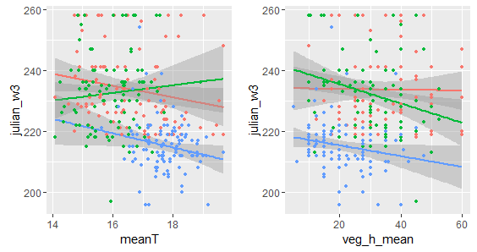

Soil T + Veg h 🡪 Ants

Global model

Model-averaged coefficients:

Estimate Std. Error Adjusted SE z value Pr(>|z|)

(Intercept) 14.9018323 4.9163765 4.9322606 3.021 0.00252 **

meanT -0.8704770 0.2981636 0.2990579 2.911 0.00361 **

populationRemmene -0.9783712 0.6411066 0.6438154 1.520 0.12860

populationTånga Hed 2.5258251 0.9379964 0.9395176 2.688 0.00718 **

veg_h_mean -0.2862303 0.1516348 0.1521094 1.882 0.05987 .

meanT:veg_h_mean 0.0190400 0.0093333 0.0093607 2.034 0.04195 *

populationRemmene:veg_h_mean 0.0006386 0.0177219 0.0177969 0.036 0.97138

populationTånga Hed:veg_h_mean -0.0356213 0.0329123 0.0329575 1.081 0.27978

Relative variable importance:

meanT population veg_h_mean meanT:veg_h_mean population:veg_h_mean

Importance: 1.00 1.00 1.00 1.00 0.63

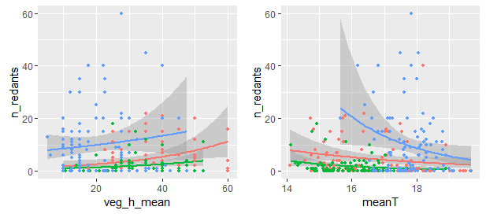

Models for each population

H

Estimate Std. Error z value Pr(>|z|)

(Intercept) 30.96917 7.94465 3.898 9.69e-05 ***

veg_h_mean -0.71874 0.21703 -3.312 0.000927 ***

meanT -1.84865 0.47138 -3.922 8.79e-05 ***

veg_h_mean:meanT 0.04552 0.01301 3.499 0.000466 ***

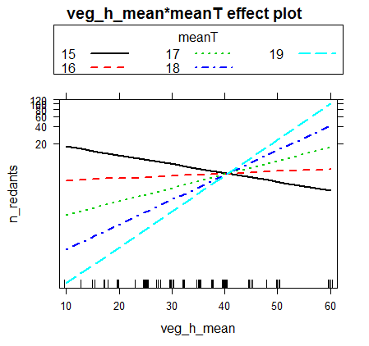

R

Model-averaged coefficients:

Estimate Std. Error Adjusted SE z value Pr(>|z|)

(Intercept) 6.599569 3.222064 3.262306 2.023 0.0431 *

meanT -0.399838 0.193770 0.196309 2.037 0.0417 *

veg_h_mean 0.009955 0.015447 0.015544 0.640 0.5219

T

Model-averaged coefficients:

Estimate Std. Error Adjusted SE z value Pr(>|z|)

(Intercept) 8.156884 4.507027 4.535791 1.798 0.0721 .

meanT -0.333477 0.253850 0.255439 1.306 0.1917

veg_h_mean 0.001629 0.008208 0.008294 0.196 0.8443

**Eggs – hurdle models / n_redants = max count in all censuses**

** **

hurdle(formula = n_eggs_max ~ scale(phen_index_avg) + scale(over_veg) + scale(n_redants) +

pop + scale(n_redants):pop, data = data8, na.action = "na.fail", dist = "poisson",

zero.dist = "binomial")

Pearson residuals:

Min 1Q Median 3Q Max

-2.0417 -0.9175 -0.5721 0.3809 8.9982

Count model coefficients (truncated poisson with log link):

Estimate Std. Error z value Pr(>|z|)

(Intercept) 1.96567 0.06074 32.360 < 2e-16 ***

scale(phen_index_avg) 0.17942 0.03790 4.734 2.2e-06 ***

scale(over_veg) 0.06622 0.03812 1.737 0.082355 .

scale(n_redants) 0.21150 0.05721 3.697 0.000219 ***

popR 0.11368 0.08356 1.360 0.173672

popT -0.01515 0.09806 -0.155 0.877196

scale(n_redants):popR 0.15575 0.11388 1.368 0.171414

scale(n_redants):popT -0.18862 0.06371 -2.960 0.003073 **

Zero hurdle model coefficients (binomial with logit link):

Estimate Std. Error z value Pr(>|z|)

(Intercept) 0.44972 0.25004 1.799 0.0721 .

scale(phen_index_avg) 0.25802 0.16338 1.579 0.1143

scale(over_veg) 0.68761 0.16863 4.078 4.55e-05 ***

scale(n_redants) 0.57135 0.29916 1.910 0.0562 .

popR 0.65271 0.45235 1.443 0.1490

popT -0.15615 0.44985 -0.347 0.7285

scale(n_redants):popR 0.02407 0.80776 0.030 0.9762

scale(n_redants):popT -0.58484 0.33756 -1.733 0.0832 .

---

Signif. codes: 0 '***' 0.001 '**' 0.01 '*' 0.05 '.' 0.1 ' ' 1

Number of iterations in BFGS optimization: 15

Log-likelihood: -948.3 on 16 Df

________________________________________________________________________________________

hurdle(formula = n_eggs_max ~ scale(phen_index_avg) + scale(over_veg), data = data8,

na.action = "na.fail", dist = "negbin", zero.dist = "binomial")

Pearson residuals:

Min 1Q Median 3Q Max

-0.9824 -0.6354 -0.4203 0.2805 5.7462

Count model coefficients (truncated negbin with log link):

Estimate Std. Error z value Pr(>|z|)

(Intercept) 1.85519 0.08383 22.132 < 2e-16 ***

scale(phen_index_avg) 0.21362 0.08067 2.648 0.00809 **

scale(over_veg) 0.03210 0.08282 0.388 0.69835

Log(theta) 0.18141 0.18866 0.962 0.33627

Zero hurdle model coefficients (binomial with logit link):

Estimate Std. Error z value Pr(>|z|)

(Intercept) 0.4990 0.1272 3.922 8.77e-05 ***

scale(phen_index_avg) 0.1794 0.1328 1.351 0.177

scale(over_veg) 0.6245 0.1413 4.421 9.83e-06 ***

---

Signif. codes: 0 '***' 0.001 '**' 0.01 '*' 0.05 '.' 0.1 ' ' 1

Theta: count = 1.1989

Number of iterations in BFGS optimization: 11

Log-likelihood: -709.9 on 7 Df

> m3<-hurdle(n_eggs_max~(scale(phen_index_avg)+scale(over_veg)+scale(n_redants))*pop,

+ data=data8,dist="negbin",zero.dist="binomial",na.action="na.fail")

> m4<-hurdle(n_eggs_max~(scale(phen_index_avg)+scale(over_veg)+scale(n_redants))*pop,

+ data=data8,dist="poisson",zero.dist="binomial",na.action="na.fail")

> AIC(m3,m4)

df AIC

m3 25 1452.661

m4 24 1935.347

> vuong(m3,m4)

Vuong Non-Nested Hypothesis Test-Statistic:

(test-statistic is asymptotically distributed N(0,1) under the

null that the models are indistinguishible)

-------------------------------------------------------------

Vuong z-statistic H_A p-value

Raw 5.235848 model1 > model2 8.2115e-08

AIC-corrected 5.235848 model1 > model2 8.2115e-08

BIC-corrected 5.235848 model1 > model2 8.2115e-08

> m1<-hurdle(n_eggs_max~scale(phen_index_avg)+scale(over_veg),data=data8,dist="negbin",zero.dist="binomial",na.action="na.fail")

> m2<-glm.nb(n_eggs_max~scale(phen_index_avg)+scale(over_veg),data=data8,na.action="na.fail")

> AIC(m1,m2) #hurdle is better

df AIC

m1 7 1433.881

m2 4 1465.190

> vuong(m1,m2) #hurdle is better

Vuong Non-Nested Hypothesis Test-Statistic:

(test-statistic is asymptotically distributed N(0,1) under the

null that the models are indistinguishible)

-------------------------------------------------------------

Vuong z-statistic H_A p-value

Raw 3.513285 model1 > model2 0.0002213

AIC-corrected 2.948273 model1 > model2 0.0015978

BIC-corrected 1.906680 model1 > model2 0.0282810

**Model with plants where n eggs > 0**

glm(formula = n_eggs_max ~ scale(over_veg) + scale(phen_index_avg) +

scale(n_redants) + pop + scale(n_redants):pop, family = "poisson",

data = subset(data8, n_eggs_max > 0))

Deviance Residuals:

Min 1Q Median 3Q Max

-3.7299 -1.9697 -0.8323 1.0595 7.7981

Coefficients:

Estimate Std. Error z value Pr(>|z|)

(Intercept) 2.02095 0.06371 31.721 < 2e-16 ***

scale(over_veg) 0.05938 0.03423 1.735 0.082805 .

scale(phen_index_avg) 0.17657 0.03742 4.719 2.37e-06 ***

scale(n_redants) 0.21768 0.05912 3.682 0.000231 ***

popR 0.12230 0.08513 1.437 0.150831

popT -0.02568 0.09740 -0.264 0.792041

scale(n_redants):popR 0.16135 0.11776 1.370 0.170620

scale(n_redants):popT -0.19413 0.06588 -2.947 0.003210 **

---

Signif. codes: 0 ‘***’ 0.001 ‘**’ 0.01 ‘*’ 0.05 ‘.’ 0.1 ‘ ’ 1

(Dispersion parameter for poisson family taken to be 1)

Null deviance: 987.36 on 179 degrees of freedom

Residual deviance: 906.93 on 172 degrees of freedom

AIC: 1557

Number of Fisher Scoring iterations: 5

__________________________________________________________________________

glm.nb(formula = n_eggs_max ~ scale(over_veg) + scale(phen_index_avg) +

scale(n_redants) + pop + scale(n_redants):pop, data = subset(data8,

n_eggs_max > 0), init.theta = 1.913018985, link = log)

Deviance Residuals:

Min 1Q Median 3Q Max

-1.8620 -0.9454 -0.4301 0.4184 2.9832

Coefficients:

Estimate Std. Error z value Pr(>|z|)

(Intercept) 2.006158 0.138736 14.460 <2e-16 ***

scale(over_veg) 0.041227 0.076707 0.537 0.5909

scale(phen_index_avg) 0.164983 0.080502 2.049 0.0404 *

scale(n_redants) 0.196512 0.141847 1.385 0.1659

popR 0.095124 0.197692 0.481 0.6304

popT 0.008186 0.215621 0.038 0.9697

scale(n_redants):popR 0.098999 0.298144 0.332 0.7399

scale(n_redants):popT -0.173062 0.158825 -1.090 0.2759

---

Signif. codes: 0 ‘***’ 0.001 ‘**’ 0.01 ‘*’ 0.05 ‘.’ 0.1 ‘ ’ 1

(Dispersion parameter for Negative Binomial(1.913) family taken to be 1)

Null deviance: 199.50 on 179 degrees of freedom

Residual deviance: 184.54 on 172 degrees of freedom

AIC: 1096.5

Number of Fisher Scoring iterations: 1

Theta: 1.913

Std. Err.: 0.245

2 x log-likelihood: -1078.456

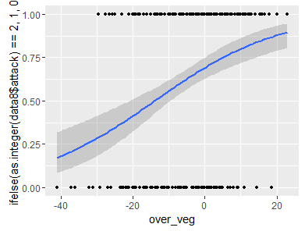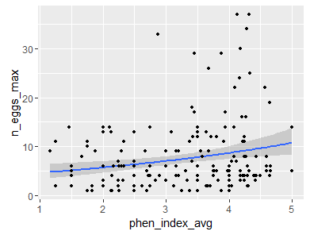

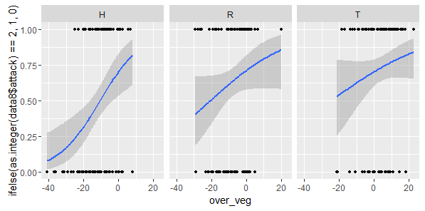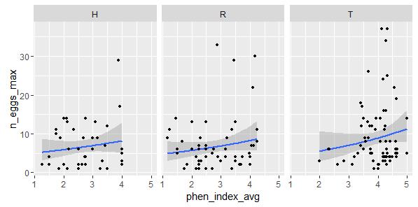

**n_redants_mean = mean of the daily max (3 sampling days / plant)**

Model-averaged coefficients:

(full average)

Estimate Std. Error z value Pr(>|z|)

count_(Intercept) 1.85236 0.08369 22.134 < 2e-16 ***

count_scale(over_veg) 0.03895 0.08353 0.466 0.6410

count_scale(phen_index_avg) 0.20655 0.08143 2.536 0.0112 *

count_Log(theta) 0.18961 0.18881 1.004 0.3153

zero_(Intercept) 0.49917 0.12724 3.923 8.75e-05 ***

zero_scale(over_veg) 0.62404 0.14131 4.416 1.01e-05 ***

zero_scale(phen_index_avg) 0.17676 0.13315 1.328 0.1843

count_scale(n_redants_mean) 0.03049 0.05862 0.520 0.6030

zero_scale(n_redants_mean) 0.01931 0.07809 0.247 0.8047

Relative variable importance:

count_scale(over_veg) count_scale(phen_index_avg)

Importance: 1.00 1.00

N containing models: 2 2

zero_scale(over_veg) zero_scale(phen_index_avg)

Importance: 1.00 1.00

N containing models: 2 2

count_scale(n_redants_mean) zero_scale(n_redants_mean)

Importance: 0.31 0.31

N containing models: 1 1

**# sum of all values, abundance corrected (only when ants present more than once), presence/absence…**

** **

Model-averaged coefficients:

(full average)

Estimate Std. Error Adjusted SE z value Pr(>|z|)

(Intercept) -1.00517 0.19187 0.19261 5.219 2e-07 ***

popR -0.77947 0.38877 0.39038 1.997 0.04586 *

popT 1.60429 0.23866 0.23954 6.697 < 2e-16 ***

scale(meanT) 0.16203 0.20222 0.20252 0.800 0.42366

scale(n_eggs_max) -0.18562 0.05684 0.05707 3.252 0.00114 **

scale(phen_index_avg) 0.33960 0.23775 0.23837 1.425 0.15425

popR:scale(meanT) -0.28802 0.40399 0.40482 0.711 0.47679

popT:scale(meanT) -0.26122 0.29800 0.29828 0.876 0.38116

popR:scale(phen_index_avg) -0.04414 0.30153 0.30276 0.146 0.88407

popT:scale(phen_index_avg) 0.31444 0.29454 0.29513 1.065 0.28668

Relative variable importance:

pop scale(n_eggs_max) scale(phen_index_avg)

Importance: 1.00 1.00 1.00

N containing models: 3 3 3

pop:scale(phen_index_avg) scale(meanT) pop:scale(meanT)

Importance: 0.71 0.50 0.50

N containing models: 2 1 1

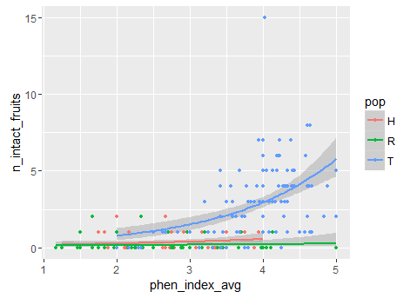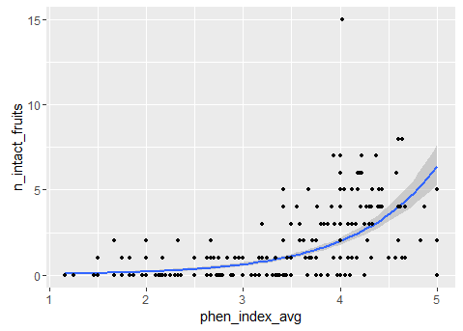

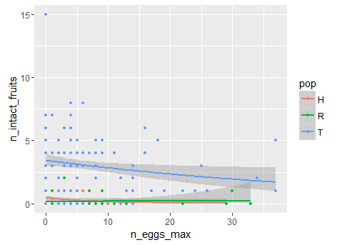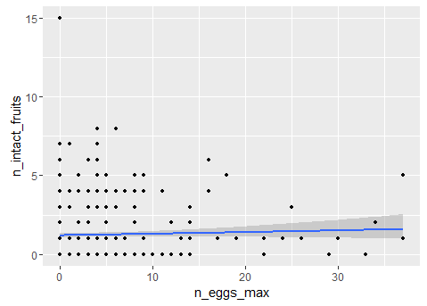



cbind(n_intact_fruits,n_fl)

Model-averaged coefficients:

(full average)

Estimate Std. Error Adjusted SE z value Pr(>|z|)

(Intercept) -1.996299 0.277656 0.278677 7.163 < 2e-16 ***

popR -0.694334 0.385250 0.386746 1.795 0.07260 .

popT 0.813909 0.321415 0.322669 2.522 0.01165 *

scale(n_eggs_max) -1.037050 0.483754 0.485025 2.138 0.03251 *

scale(phen_index_avg) 0.545473 0.175731 0.176280 3.094 0.00197 **

popR:scale(n_eggs_max) 0.647125 0.544826 0.546454 1.184 0.23632

popT:scale(n_eggs_max) 0.698116 0.495181 0.496445 1.406 0.15966

popR:scale(phen_index_avg) -0.132960 0.319684 0.320086 0.415 0.67786

popT:scale(phen_index_avg) -0.038028 0.149225 0.149692 0.254 0.79946

scale(veg_h_mean) -0.010895 0.041617 0.041732 0.261 0.79405

scale(meanT) 0.005078 0.039951 0.040101 0.127 0.89924

Relative variable importance:

pop scale(n_eggs_max) scale(phen_index_avg) pop:scale(n_eggs_max)

Importance: 1.00 1.00 1.00 0.83

N containing models: 5 5 5 4

pop:scale(phen_index_avg) scale(veg_h_mean) scale(meanT)

Importance: 0.20 0.16 0.13

N containing models: 1 1 1

